Thomas J Gustafson

ISQA 4900 Activity 2

**General design of website:**

Simple website introducing Dr. Fereydoon Namavar and his nano-film research for orthopedics. Website consists of three .htm files that have links to each other:

1. NamavarMain.htm – short description/bio of Namavar and his research
2. IBAD.htm – Discusses the lab and equipment
3. Apprentice.htm – Discusses me, as Namavars Research assistant and short bio

Each page will have a common title header “Namavar and Me!!” Styling controlled by NamavarStyle.css.

**Links**

1. Each page will contain links to all three pages underneath the title header
2. Wiki link to Ion Beam Assisted Deposition: <https://en.wikipedia.org/wiki/Ion_beam-assisted_deposition>
3. Wiki link to Physical Vapor Deposition: <https://en.wikipedia.org/wiki/Physical_vapor_deposition>

Screenshot and notes as of 9/3/2018

First Commit of project Activity 2

commit 6c7de3c3487a0adada790b4a6dbf6db2ab79aaf2 (origin/master)

Author: newtons4th <tgustafson@unomaha.edu>

Date: Wed Aug 28 20:31:58 2019 -0500

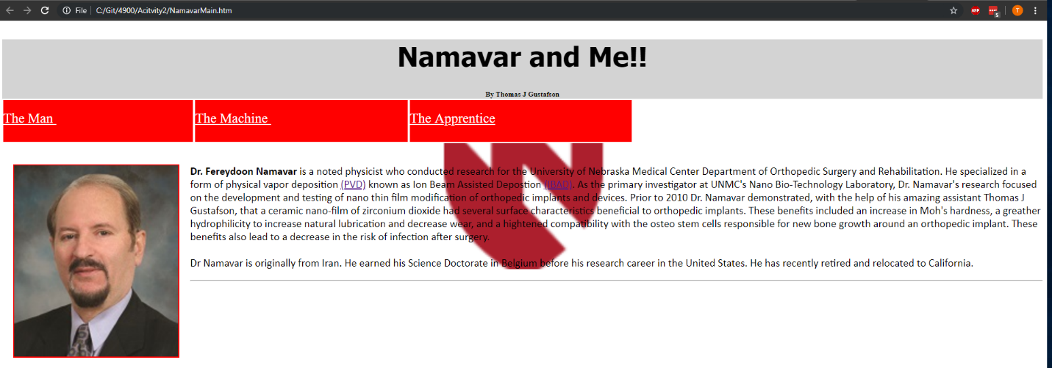

Tested on laptop screen and with external display(shown). Aesthetic format changes between the two are acceptable. UNMC shield needs to be more transparent for readability (less of an issue with external monitor). All links are functioning (items 1-3 above).

[master df0939b] Second commit for activity 2

df0939b90c504677e5246eb46787376c063698db

(First commit was done to the wrong folder as I’m learning Git Hub)

Made UNMC shield more transparent. Started second page “the machine.” Aligned figures of IBAD equipment with captions. Screenshot of figures and body:

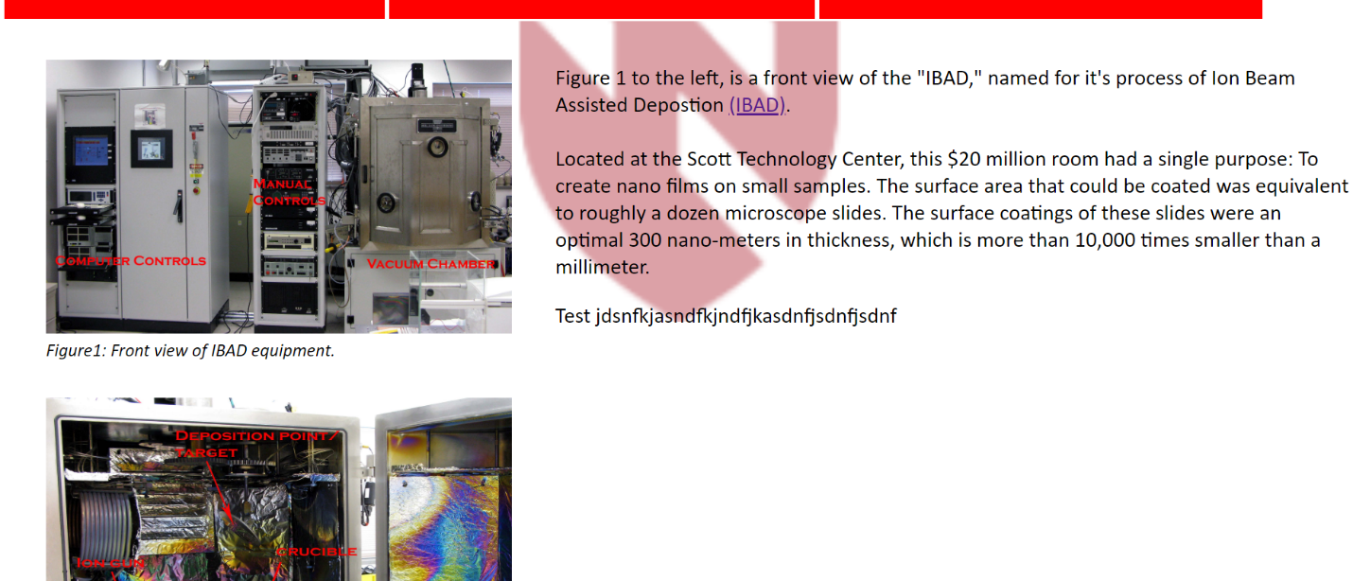

Third Commit

commit 244f05db2a5cded5674640d1a2127a16ec452145

Added content and headshot to apprentice page. Site finished. Need to create readme file.

Fourth Commit

Commit 3761c6c6ff6459678d1a359040b0e6d1da30d31d

Added readme file

Additional Questions:

1. What is the value of having a CSS in one page HTML in other pages? Why not simply embed the CSS in each web page?
   1. Using a single CSS page allows for easier control of styling a website with multiple pages. The CSS acts as a single object controlling the style over every web page, also automatically styling divs with common names across pages. This method also makes for easier code readability and organization.
2. There are many cloud-based document replication facilities such as DropBox, Box, Microsoft OneDrive. What is the advantage of using a tool like Git and GitHub over simply using something like Box to manage code?
   1. Git hub makes tracking changes over a group project easier. Each commit shows a contributor name and a note about changes that were made. The Git Bash command line style interface is faster than using a browser-based GUI interface like Box. Git can also be controlled using cmd or powershell (and other tools), which lends to the possibility of automation.